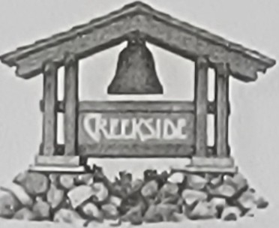

# RULES & REGULATIONS

1. **INTRODUCTION.** At all times, these Rules and Regulations ("Rules") will be interpreted in a reasonable fashion consistent with the Mobilehome Residency Law (MRL), as it may be revised from time to time. These Rules contain standards applicable to Creekside Community ("Creekside") for the protection of the interests of all residents and management. These Rules are part of the Lease Agreement and are a requirement of tenancy. Please read these Rules carefully and keep them on file. These Rules constitute a binding agreement between you and Creekside. However, these Rules are not permanent or irrevocable, and may be changed at any time in accordance with Civil Code Section

798.25. Changes to the MRL occur each year, and you will be provided with a copy of the MRL each year. If you do not understand any of these Rules, please contact management.

1. **UNIVERSAL RULE.** The universal rule is always applicable and controlling unless a more specific rule exists, in that residents must conduct themselves in a reasonable manner, so as not to adversely affect other residents, management or property belonging to other residents or management. In other words, no nuisance, breach of quiet enjoyment, annoyance, violation of laws or regulations or injurious conduct or condition is permitted, even if not specifically described or prohibited in these Rules.
2. **REGISTERED OWNERS AND GUESTS.** At all times, at least one (1) person occupying each mobilehome in Creekside on a full-time basis must be the "registered owner" of the mobilehome. The residents of the mobilehome must be the owner, the relatives of the owner, or must reside with the owner as provided herein, in the Lease Agreement, and in the MRL. A resident may also be a person who is subletting a mobilehome in Creekside, with approval from management, in advance and in writing.
   1. In addition, a person who resides in a mobilehome in Creekside for in excess of twenty (20) consecutive days or thirty (30) days in a calendar year, and who is eligible for residency under the terms herein, shall be deemed a resident upon execution of the then-current residency documents. Occupancy of each mobilehome is limited to two (2) persons per bedroom plus one (1) person. A bedroom is defined as a room with at least one (1) closet, window and exit that was designed and constructed as such by the manufacturer of the mobilehome. All residents shall be registered with management.
   2. Guests are welcome in Creekside, provided that their visits are less than or equal to twenty

(20) consecutive days or thirty (30) days in a calendar year. Such guests are known herein as house guests.

* 1. Guests using the recreational and other facilities in Creekside must be accompanied by their host resident at all times. House guests may use the facilities without being accompanied by their host resident, provided that they are registered with management in the house guest log book. Residents are asked to use reasonable discretion regarding the number of guests they bring into Creekside, including house guests. If the number of guests brought to the swimming pool, for example, interferes with other residents' right to enjoy the swimming pool, then that is too many guests. All residents,

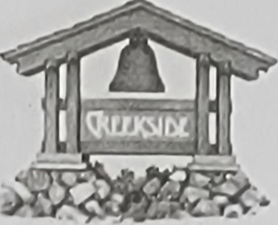

# RULES & REGULATIONS

guests, agents and contractors must observe the speed limit and all posted rules, traffic signs and curb markings in Creekside, which are incorporated by reference as though fully set forth herein.

1. **All-AGE COMMUNITY.** Creekside is an "all-age" community with no minimum age requirements. At least one (1) resident of each space must, however, have the legal capacity to enter into a contract as a result of being at least eighteen (18) years of age or being adjudged emancipated by a court of competent jurisdiction. PERSONS OF ALL AGES MAY RESIDE IN CREEKSIDE IN ACCORDANCE WITH THE FAIR HOUSING ACT AND THE FAIR HOUSING AMENDMENTS ACT OF 1988. RESIDENCY IS NOT CONDITIONED UPON OR RESTRICTED BY THE AGE OF ANY RESIDENT OR GUEST. THERE IS NO AGE PREFERENCE EXPRESSED BY MANAGEMENT ANY UNLAWFUL DISCRIMINATION BY MANAGEMENT OR ANY RESIDENT OR GUEST MAY BE REPORTED TO APPROPRIATE GOVERNMENT AUTHORITIES.
2. **CONDUCT.** Actions by any person of any nature that may be dangerous, injurious, a nuisance, a breach of quiet enjoyment, disturbing, annoying, obscene, offensive to the senses of other residents, profane, tortious, damaging, illegal, indecent, or which may create a health and safety risk or unreasonable interference with the rights and privileges of others in Creekside, are prohibited. This includes, but is not limited to, any unusual, disturbing or excessive noise, intoxication, quarreling, threatening, fighting, immoral or illegal conduct, profanity, illegal activity, dangerous or negligent conduct or conditions, or objectionable or abusive language or conduct. The use, display or brandishing of any weapon, including, but not limited to, bows and arrows, BB/pellet/dart guns, slingshots, bats or clubs, martial arts weapons, guns, knives, fireworks and flares, is also prohibited. Persons under the influence of alcohol, or any other controlled substance, shall not be permitted in any area of Creekside that is generally open to residents and guests.
   1. All equipment that transmits music or other sound, televisions, musical instruments and other devices must be used so as not to disturb others. Mobilehomes may amplify sound so as to disturb and annoy other residents, especially sound in the bass range. "Ham" or "CB" radios or other radio transmitters that cause interference to telephone, television or radio reception may not be operated in Creekside. No exterior "ham" and "CB" antennas are allowed.
   2. Residents and guests shall not encroach or trespass on any other resident's space or any area not generally open to residents and guests. All Creekside property that is not generally open to residents and guests, including, but not limited to, gas, electric, sewer and water connections, other equipment connected with utility services, and tools and equipment belonging to Creekside, shall not be used, tested, examined, opened, adjusted, inspected, tampered with or interfered with in any way by residents and guests for safety reasons.
   3. Except for barbecues approved by management, in advance and in writing, and fireplaces and other appliances in a resident's mobilehome, no fires are permitted in Creekside.
   4. The mobilehomes and spaces in Creekside shall be used for private residential purposes only, unless a Home Occupation Permit has been obtained as provided below. Any activity that

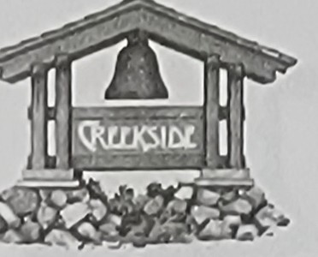

## RULES & REGULATIONS

increases foot or vehicular traffic, or dust, noise or odors in Creekside, or that is inconsistent with the zoning and permits under which Creekside operates, is prohibited. Prohibited conduct and actions include leasing, subleasing, selling and exchanging mobilehomes (except as permitted in accordance with these Rules and the MRL), and actions that may affect the insurability of Creekside or increase the cost of its insurance. Home businesses must be approved by management, in advance and in writing, and resident must obtain a Home Occupation Permit from the City of San Luis Obispo and comply with all of the conditions thereof.

1. **CLUBHOUSE.** The main room and kitchen in the clubhouse may be reserved by residents for private functions. Other residents shall still have access to the game room, meeting room/library and restrooms. Reservations shall be taken by management on a first come, first served basis, so long as the date and time of the function does not conflict with any other planned function. The host resident must be present during the entire function, and he or she is responsible for the behavior of his or her guests and for making sure the clubhouse and contents thereof are not damaged during the function. Tablecloths or other protection must be used on wood tables so they are not damaged by food, beverages or crafts. The host resident shall reimburse Creekside for the cost of repairing any damage to furniture or flooring that occurs during the function. Use of the clubhouse for functions may not disturb management in the office or the residents of the mobilehomes near the clubhouse.
   1. There will be no charge for the use of the clubhouse, but the host resident may be required to pay a cleaning deposit if the function is not hosted by a resident and/or if all residents are not allowed to attend. The host resident is responsible for returning the clubhouse to the clean state it was in before the function. If the resident does so, the deposit will be returned. If the resident fails to do so, the deposit will be applied to the cost of the cleaning and any unused amount will be returned. If the resident fails to do so and the cost of the cleaning exceeds the deposit, the deposit will not be returned and the resident will be billed for the excess and must pay it immediately.
   2. All recyclable materials generated during a function shall be placed in the recycling bins and not in the trash. The host resident is responsible for instructing his or her guests to recycle. Full trash cans and recycling bins shall be emptied, and full trash bags may be placed in the Creekside trash trailer or left in the trash can area of the pool deck. Replacement trash bags are located under the stove in the kitchen.
   3. All functions must be over, and the clubhouse must be cleaned, by 10:00 p.m. The keys to the clubhouse may be dropped in the rent check slot or returned to the office by 10:00 a.m. the next morning.
   4. Balloons, signs and other decorations shall not be hung or attached to trees, light posts or anywhere outside of the clubhouse, and tape, tacks and pins shall not be used on the walls in the clubhouse as they remove and/or damage the paint.
   5. Parking for functions in the clubhouse is limited. The host resident is responsible for controlling guest parking and ensuring that guests do not block driveways or park in other

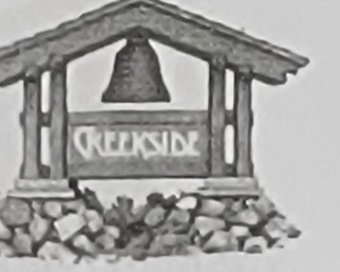

Cnu l\')IOL COMMUNITY

## RULES & REGULATIONS

inappropriate locations. A couple of spaces may be barricaded for barbeques, but as many spaces as possible shall be used for guest parking.

* 1. No copyrighted videos, movies or other materials may be shown on the clubhouse television without a license from the Motion Picture Licensing Corporation.
  2. All functions in the clubhouse must be in full compliance with these Rules and the other residency documents. Resident must therefore provide management with information regarding the function, so an evaluation can be made as to whether it is in compliance with these Rules and the other residency documents. Clubhouse parties are not to be pool parties, because too many guests around the pool are a safety hazard and interfere with other residents' right to use the pool. Residents and guests only have the right to use the recreational and other facilities in Creekside, including the clubhouse, if they comply with these Rules and the other residency documents. In using such facilities, all residents and guests are expected to observe the rules of good conduct and to exercise good judgment. Creekside reserves the right to eject and ban from the recreational and other facilities, including the clubhouse, any person who may be a nuisance or who is causing a disturbance. Creekside shall be the sole judge of whether a particular person is a nuisance or is causing a disturbance.

1. **PLAYGROUND AND PARK.** The playground and park are open during daylight hours.
   1. Compliance with Laws Concerning Child Welfare: Residents are required to comply with all applicable laws concerning child welfare when they have parental or custodial responsibility for any child in the playground or park.
   2. Compliance with Curfew Laws: All persons subject to curfew laws are required to comply with them as they may be revised from time to time.
2. **CAUTION - ADJACENT CREEK.** The creek bank is continuously altered by the water in the creek and is potentially dangerous, particularly during the rainy season. It is therefore wise to avoid the creek bank at all times. The paths in the creek area are made of natural materials (not paved), and tree roots may create uneven areas and trip hazards. Caution is urged when walking in the creek area, especially for persons who are unsteady on their feet.
3. **SKATEBOARDING.** Skateboarding is allowed in Creekside for transportation only, and proper safety equipment is recommended. Performing tricks on skateboards is not allowed.
4. **NO FLYING OBJECTS.** To avoid injury to persons and damage to mobilehomes and other

property, games involving flying objects of any kind are not permitted in Creekside.

1. **BICYCLE RIDING AND ROLLER SKATING.** Bicycle riding and roller skating are permitted in Creekside, but only if all traffic regulations and good safety practices are observed. Bicycle riding and skating are not permitted on other residents' spaces or on sidewalks. Proper safety equipment is

recommended. PLEASE NOTE: State law requires helmets on fill children riding bicycles.

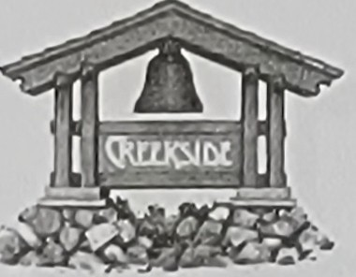

CllEl:.I\SIDC:. COMMUNITY

# RULES & REGULATIONS

1. **MOBILEHOME AND SPACE MAINTENANCE.** Each resident shall, during his or her tenancy and/or upon the sale of his or her mobilehome, be required to maintain the exterior of his or her mobilehome and his or her space in compliance with these Rules, the other residency documents and all applicable laws.
   1. Only outdoor furniture and barbecues approved by management, in advance and in writing, may be placed or used on any resident's patio, porch, deck, including awning enclosures, yard, or other portions of the space. Such approval shall not be unreasonably withheld.
   2. No towels, rugs, clothing or other materials of any description may be hung in public view outside of any resident's mobilehome at any time.
   3. Dangerous Materials and Hazardous Wastes: Any material or substance that creates a threat to health and safety, threatens damage to property or induces or harbors, or may tend to induce or harbor, offensive odors, infectious plant disease and/or noxious insects, rodents or reptiles is strictly prohibited. No flammable, combustible, explosive or environmentally hazardous fluids, materials, chemicals or substances may be stored on any resident's space {except those customarily used for normal household purposes, so long as they are in quantities customarily used for normal household purposes). No resident may keep in his or her mobilehome, on his or her space, in a shed or elsewhere in Creekside any hazardous materials in excess of the quantities customarily used for normal household purposes. Additionally, no resident may engage in any activity in Creekside that causes an environmental hazard or violates any law relating to environmental protection, hazards or similar laws. This includes, but is not limited to, changing the oil in any motor vehicle in any common area of Creekside. In addition, no resident may allow any environmentally hazardous grease, or any substance defined as environmentally hazardous, to be placed on any surface in Creekside or disposed of anywhere in Creekside, including, but not limited to, trash cans, trash bins, surface areas, the sewage disposal system, or any other trash, garbage or disposal area in Creekside. Such substances must be physically removed from Creekside and disposed of elsewhere in compliance with all applicable laws. In addition to any other remedies allowed by law, any resident who engages in any environmentally hazardous activity in Creekside shall indemnify and hold Creekside harmless from liability for such activity, including any compensatory damages, statutory damages, punitive damages and attorney's fees incurred by Creekside as a result of such activity.
   4. Exterior Painting: The exterior paint on all residents' mobilehomes, accessory structures and equipment shall be properly maintained. Proper maintenance shall include, but not be limited to, repainting whenever the paint begins to fade, peel, flake, chip or deteriorate in any manner that detracts from the aesthetics of Creekside. Spray painting may only be performed by a licensed painter. All colors must be approved by management, in advance and in writing.
   5. Damage: If any portion of the exterior of any mobilehome, accessory structure or equipment, or the space itself, is damaged, the damage must be repaired or replaced within thirty {30) days of receipt of notice thereof. This includes, but is not limited to, damage to the siding, awning supports, downspouts, skirting, porch or shed(s).

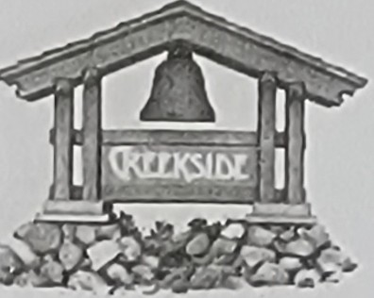

**CllEEI\SIDE COMMUNITY**

# RULES & REGULATIONS

* 1. Concrete: All concrete, asphalt and other surfaces shall be kept clean and maintained free of oil and all other sticky or oily substances.
  2. Utility Pedestals: The utility pedestals at each space must be accessible at all times. No structures may be installed and no shrubbery may be planted that would obstruct the utility pedestals so as to impede the reading thereof. If one of Creekside's utility shut-off valves is located on resident's space, it must be kept uncovered and accessible at all times. No resident shall connect, except through existing electrical or natural gas outlets or water pipes on the space, any apparatus or device for the purpose of using electricity, natural gas or water.
  3. Licenses: All mobilehomes in Creekside must bear current registrations issued by the appropriate government agency.
  4. Maintenance Charges for Premises Cleanup: Prior to resale, or at any time during resident's tenancy, Creekside may conduct a survey of the exterior of resident's mobilehome and the space for compliance with these mobilehome and space maintenance standards. Creekside may require the mobilehome and space to be brought into compliance with these standards by giving resident a fourteen (14) day notice pursuant to Civil Code Section 798.36(a), as it may be revised from time to time, or a seven (7) day notice pursuant to Civil Code Section 798.56{d), as it may be revised from time to time. Should resident fail to perform the maintenance specified in the notice within fourteen (14) days, Creekside will arrange for the maintenance to be performed and resident will be required by Section 798.36(a) to reimburse Creekside for the cost thereof. Repeated non-compliance with this rule may result in service of multiple seven (7) day notices as provided in Section 798.56(d), and may lead to termination of tenancy. Creekside encourages all residents to be responsive to management's verbal and written compliance requests, so more serious consequences may be avoided.
  5. All mobilehomes and spaces shall have approved awnings on their carports and side patios, skirting to match and landscaping. Spaces with special circumstances will be evaluated individually. In addition, residents may have fixtures such as sheds, cabanas, room additions, porches, patios, decks and fences, so long as such fixtures are approved by management, in advance and in writing. The mobilehome and fixtures shall be maintained in good condition at all times.
  6. A maximum of two (2) sheds, not to exceed a total of one hundred twenty (120} square feet in area and eight (8) feet in height, will be permitted. Such sheds must be constructed of aluminum or hardboard siding and their design and appearance must be approved by management, in advance and in writing. Sheds shall be located at the rear of the space, on the carport side of the mobilehome. Spaces with special circumstances will be evaluated individually. Room additions, gazebos and enclosed porch rooms, if they are approved by management, in advance and in writing, and/or permitted by the appropriate government agency, must be sided and skirted to match the mobilehome and awnings.

I.) Simulated masonry and other artificial materials will not be permitted.

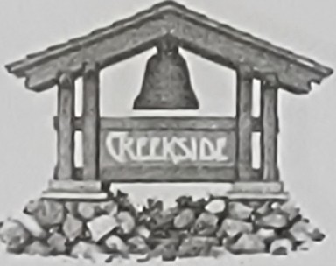

# RULES & REGULATIONS

1. All structures and alterations to spaces must be approved by management, in writing, before installation. Permits, when required, must be obtained from the appropriate government agency. Management approval, in advance and in writing, is required for all replacement or additional awnings, porch enclosures, room additions, sheds, porches, patios, decks, ramps and like installations.
2. All entrances to the mobilehome must have permanent steps. All porches and steps must be constructed in compliance with state law as specified in Title 25, Chapter 2, of the California Code of Regulations. A copy is available in the office for review. Porches and steps constructed of aluminum or plywood must be carpeted and maintained in good repair. Porches and steps made of wood planking need not be carpeted. Staining or painting is recommended.
3. All mobilehomes, materials and structures must be coordinated with compatible colors.
4. Important: The body and trim of the mobilehome, or any other fixture or structure on the space, must be painted in muted colors approved by management, in writing, prior to the commencement of painting. Mobilehomes may be repainted to their original color without approval from management. Color charts are available in the office.
5. Air conditioners and water softeners may be installed so long as they are minimally visible to other residents. Air conditioners may not work at every space due to limitations in Creekside's electrical system.
6. Repainting of mobilehomes and repair or replacement of deteriorated porch carpeting, skirting, bent or broken awning columns, awnings, siding, porches, steps, decks, fences and landscaping will be required on a regular basis. Security bars may be affixed to the inside of windows for easy removal in the event of an emergency, and may not be affixed to the outside of the mobilehome.
7. **STORAGE.** State law prohibits storage of anything under the mobilehome, with the exception of the tongue, axles and wheels used to transport the mobilehome. No storage is permitted in public view on the space, with the exception of outdoor furniture and barbecues. Trash cans and recycling bins shall be stored at the rear of the carport. Clotheslines, equipment, tools, boats, camper shells, trailers and inoperative vehicles are not permitted in public view on the space. Storage hidden from public view by an approved fence may be permitted, provided it does not interfere with access to the utility system and meters.
8. **REPLACEMENT MOBILEHOMES.** Replacement mobilehomes will be new or no more than one

{1) year old, and no less than fourteen {14) feet wide. All replacement mobilehomes must be approved by management, in writing, before they arrive in Creekside. It is resident's responsibility to ensure that a plot plan is prepared and approved by management, in advance and in writing, and that all necessary permits are obtained and copies thereof are given to management. The colors of any replacement mobilehome must be approved by management, in advance and in writing, and a color sample identical to the color to be used must be submitted to management. Replacement mobilehomes will

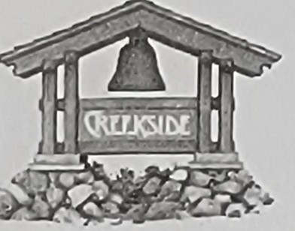



## RUl!ES & REGULATIONS

be placed on piers for a low profile, so as not to exceed twelve (12) inches under the frame of the mobilehome at the highest point of the space:

* 1. Should resident choose to replace a single-wide mobilehome with a double-wide mobilehome during the term of his or her Lease Agreement, including any extensions thereof, the rent charged for the space shall be adjusted in keeping with Paragraph 7C of the Lease Agreement.

1. **FENCES.** All new fences shall be between five (5) and six (6) feet in height, and the design and materials shall be approved by management, in advance and in writing. Wood fences must be of solid board-to-board configuration and must be "good neighbor" fences with the boards on the outsides of the frames. Fences are permitted on the rear half of the space only. Spaces with special circumstances will be evaluated individually. Gates must be constructed to provide easy access to the utility pedestal. Fences in non-compliance with this rule or poor repair will be removed upon resale or replacement of the mobilehome.
2. **LANDSCAPING AND MAINTENANCE.** Landscaping and maintenance are the keys to creating a better neighborhood, thereby protecting resident's investment in his or her mobilehome and Creekside. Everyone associated with Creekside is committed to taking all reasonable steps to ensure that Creekside remains a beautiful place to live.
   1. Creekside is known throughout the area for the beauty of its grounds and the pride of ownership displayed by Creekside residents. These high standards have been recognized by the Obispo Beautiful Association and Creekside is committed to maintaining and even improving upon these standards.
   2. These standards apply to all mobilehomes in Creekside, and will be reviewed periodically for compliance. Reasonable discretion will be used in determining compliance. All changes to the landscape and hardscape (concrete walks, patios, decks, steps, etc.) must be approved by management, in writing, prior to the commencement of work.
   3. landscaping: Trees and shrubs should be natural and of medium size, possessing no adverse characteristics that could cause damage to the mobilehome, accessories, utilities or streets. Any plants, trees, shrubs or other landscaping possessing such adverse characteristics may be required to be removed and/or trimmed. Resident shall be responsible for such removal and/or trimming, except as specified at Rule 15(f) below and in Civil Code Section 798.37.5. Resident shall also be responsible for any damage or injury caused by his or her failure to care for such landscaping.
   4. All plant materials must be approved by management, in advance and in writing. Approved ground cover shall consist of lawns, natural shrubs and/or bedding plants that do not have control problems like bamboo. Rock may be used as a backdrop or accent to the plant materials, provided it is a natural variety (not dyed or artificially colored) and a type approved by management, in advance and in writing. All landscaping must be weeded, trimmed and otherwise maintained in a neat and attractive state.

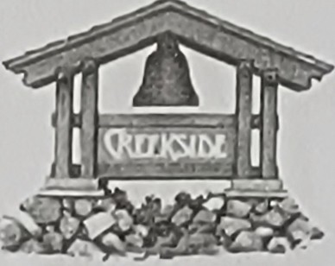

## RULES & REGULATIONS

* 1. Vegetable gardens may be planted so long as they are well maintained and on the rear half of the space. Spaces with special circumstances will be evaluated individually.
  2. Residents are responsible for maintenance of all landscaping on their spaces, with the exception of trees. Responsibility for maintenance and removal of trees shall be determined by Civil Code Section 798.37.5, as it may be revised from time to time.
  3. Irrigation: Drip irrigation is recommended wherever possible for the most efficient use of water. All irrigation should be installed so as not to create excessive run-off onto neighboring spaces or the streets.
  4. Please be mindful of the importance of water conservation. We live in a coastal desert region.
  5. Statuary: Statuary, regardless of size, must be approved by management, in advance and in writing. Painted figures, birdbaths, windmills, sundials and other items may be approved, however management reserves the right to disapprove such items.
  6. IMPORTANT: Landscape plans or sketches will be required for all modifications to the space.

1. **UTILITIES.** Creekside's electrical system is individually metered, and, depending on the space, has varying capacities for delivering power. Each electrical pedestal is equipped for standard 60-cycle, SO amperes, 120/240 volt service. Such service is limited and resident is required to obtain approval from management, in writing, before adding any major appliance such as a dryer or air conditioner. Permits from the Department of Housing and Community Development are required for alterations to utility systems. Resident warrants that his or her existing mobilehome, appliances and equipment are compatible with Creekside's electrical system and do not exceed the foregoing rating. If resident's mobilehome, appliances and equipment are not compatible with Creekside's electrical system, resident agrees, at his or her expense, to perform the alterations to make them compatible.
   1. No metallic objects shall be placed in contact with the gas delivery lines; such contact disrupts the effectiveness of the cathodic protection system that protects the gas lines from corrosion. This includes gas shut-off wrenches, which may be kept nearby but not in contact with the gas lines.
   2. The meter area must be accessible at all times for reading and maintenance purposes. Dogs may not be kept in the meter area, thereby restricting access thereto. Screening enclosures may be permitted, provided they are easily removable, allow proper ventilation and provide clear sight lines for meter reading. Approval from management, in advance and in writing, is required for all such enclosures.
   3. IMPORTANT: The utilities in Creekside are underground. Approval from management, in writing, is required before resident may dig any hole deeper than twelve (12) inches. Resident and his or her agents will be held responsible for any damage to the underground systems.

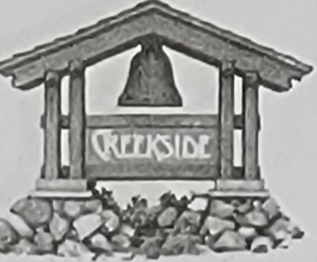

# RULES & REGULATIONS

1. **SATELLITE TELEVISION SYSTEM AND ANTENNAS. A** satellite television system is available to all Creekside residents at an additional charge. Connection to the system must be made by Creekside employees or agents, and any resident or agent who performs unauthorized work on the system will be held responsible for any damage thereto. Because the system provides local stations and satellite programming, television antennas, except satellite dishes or antennas less than one (1) meter in diameter, are not permitted. Satellite dishes must be installed at the rear of the mobilehome in keeping with the manufacturer's specifications, positioned for minimum visibility, and must not damage any property belonging to Creekside.
2. **YARD SALES.** Residents are permitted to conduct yard sales if the following guidelines are followed: No yard sales shall start before 9:00 a.m. No signs shall be posted in any Creekside common area advertising the sale. The resident conducting the sale is responsible for monitoring parking by attendees, who may only park in front of the mobilehome where the sale is held.
3. **SIGNS.** Signs may be posted on the space in keeping with Civil Code Section 798.70 regarding "For Sale" signs, and Civil Code Section 798.Sl(e) regarding political signs, as they may be revised from time to time. No other signs may be posted, with the exception of "Neighborhood Watch" signs no larger than twelve (12) inches by twelve (12) inches displayed in residents' windows. The flag of our country may be flown at any time if it is properly displayed. No "Open House" signs or signs of any kind may be placed in common areas or on the streets of Creekside.
4. **DRAINAGE.** Drainage on and from the space shall be the responsibility of resident. Precautions should be taken to ensure proper drainage of all roofs, yards and landscape areas. Downspouts and gutters should be designed to carry water to the nearest street. Residents should avoid letting water drain under their mobilehomes.
   1. Curb ramps may be installed by residents, provided that they rest on the concrete gutter and not on the asphalt. Residents are responsible for keeping ramps free of debris so they do not interfere with drainage in the gutters.
   2. Washing of streets and driveways is not permitted because of the damage water does to asphalt. Car washing is permitted ONLY in the designated car wash area. Residents may wash their mobilehomes, but they are urged to practice water conservation at all times.
5. **TRASH REMOVAL.** Creekside provides weekly curbside removal of household trash, yard trimmings and recyclable materials. All such material shall be placed at the curb no later than 8:00

a.m. on trash day, and no earlier than 12:00 p.m. the previous day. Trash must be in sealed plastic

bags. Trash cans are not permitted curbside and will not be emptied by Creekside employees. Yard trimmings may be bagged or tied in bundles no more than six (6) feet long. Recycling of all materials accepted by the local recycling contractor is mandatory. Creekside employees, after a warning notice has been issued, will not pick up trash with recyclable materials in it. Recycling benefits everyone by reducing trash costs. The trash trailer will be parked in the northwest corner of Creekside when it is

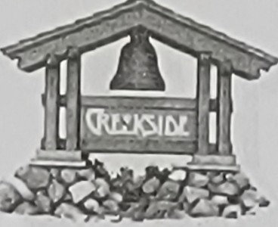

# RULES & REGULATIONS

not being used by Creekside employees, and residents may deposit trash directly into the trailer between the hours of 7:00 a.m. and 10:00 p.m. Residents may not deposit trash into the trailer between the hours of 10:00 p.m. and 7:00 a.m. Appliances and bagged or bundled yard trimmings may be left in designated areas near the trailer. Cardboard boxes, if flattened, may also be left near the trailer. Residents are asked to keep the area near the trailer free of refuse. Contractors and other residents' agents are not permitted to use the trailer. Trash cans are permitted as receptacles for

plastic bags, but they should be stored at the rear of the carport or in the utility area for minimum visibility from the street.

1. **PETS.** Each household may have two (2) pets (dogs and/or cats) in the mobilehome or on the space, if a Pet Agreement is on file with management. The Pet Agreement is incorporated by reference as though fully set forth herein. Resident agrees to comply with the Pet Agreement and further agrees to remove his or her pets from Creekside if the Pet Agreement is not complied with. All pets shall be kept reasonably quiet, and resident is responsible for ensuring that his or her pets do not disturb other residents. Dogs shall be on leashes on Creekside streets and in Creekside common areas, except in the creek area where they may be off leash if properly supervised. Residents must clean up after their pets at all times. Residents may not leave food out at night for cats or other animals, because doing so attracts other cats and raccoons.
2. **VEHICLES AND PARKING.** State law and these Rules prohibit parking vehicles on the streets of Creekside that block the fire lanes or restrict passage for emergency vehicles. All streets in Creekside are designated as fire lanes.
   1. IMPORTANT: All required "No Parking" signs authorizing the towing of vehicles parked in violation of these Rules are posted. In the event that a vehicle in Creekside is parked in violation of these Rules, management may tow the vehicle out of Creekside at the vehicle owner's expense after giving the owner notice pursuant to Civil Code Section 798.28.5. All residents should carefully review each of the vehicle and parking rules set forth below.
   2. Maximum use will be made of resident's driveway and carport prior to parking in the streets. There is NO parking in the streets after 10:00 p.m. Vehicles parked in the streets after 10:00

p.m. may be towed in accordance with Civil Code Section 798.28.5, as it may be revised from time to time.

* 1. Guest parking is provided in certain areas of Creekside. Guest parking is not for overnight parking of occupied recreational vehicles, and storage of unused vehicles in guest parking is prohibited.
  2. Parking in guest parking shall not exceed twenty (24) hours at a time. Maximum use will be made of resident's driveway and carport prior to using guest parking, given that at least two (2) vehicles may be parked at each space.
  3. Storage of inoperative vehicles is not permitted at any space or in guest parking. Campers, trailers, motorhomes and trailered boats are not permitted at any space. Small vans, pickups with

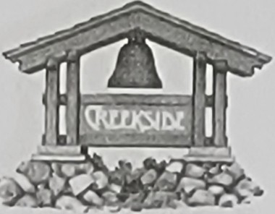

## RULES & REGULATIONS

camper shells, and small motorhomes used for everyday transportation may be parked at the space if they fit in the carport.

* 1. Guests may park in front of the space they are visiting and not in front of another resident's mobilehome. No mechanical repairs, except for emergencies, are permitted at the space. No spray painting, changing automotive fluids, motor washing or other automotive work is permitted. Any spilled fluids must be cleaned up immediately and properly disposed of pursuant to Rule 12(c) above.
  2. The Creekside speed limit is safe and slow, no more than ten (10) miles per hour in any case, and must be observed by all residents and guests. All vehicles must have legal muffling devices and no loud motorcycles will be permitted. All STOP signs and other traffic signs must be observed.

1. **RESPONSIBILITY. LIABILITY AND INSURANCE.** Creekside is not responsible for losses of any nature suffered by resident in Creekside, except as caused by management's willful misconduct or active negligence. Resident agrees by signing these Rules and his or her Lease Agreement to hold Creekside harmless for any loss or liability arising out of resident's use of his or her mobilehome, the space or its improvements, or occurring while on Creekside premises, including any loss in connection with mobilehomes, vehicles or other property owned by resident and parked in Creekside.
   1. Resident understands and acknowledges that Creekside does not provide insurance for damage to or loss of resident's mobilehome, accessory structures, household goods, furnishings or other personal property. Resident must therefore obtain such insurance in an amount equal to the value of those items, plus the value of resident's vehicles. Such insurance shall include, but not be limited to, liability coverage of not less than $100,000.00 for bodily injury and property damage occurring on the space as a result of the negligence of resident or resident's guests. Proof of such insurance, including confirmation that Creekside will receive notice of its expiration or cancellation date, must be provided to management (a) by resident within sixty {60) days of the date on which resident signs his or her Lease Agreement; and (b) by any person to whom resident's Lease Agreement is assigned ("Assignee") within sixty (60) days of the date on which Assignee signs the Assignment of Lease Agreement attached as Exhibit 110" to the Lease Agreement. In addition, Creekside must receive notice if, and only if, such insurance expires or is cancelled. Creekside does not require annual notices regarding the renewal of such insurance, and will assume unless it hears otherwise that such insurance is in good standing. Should resident or Assignee's insurance be allowed to lapse, Creekside may, at its option, secure coverage in its place with the cost of said coverage to be additional rent due under the Lease Agreement. However, this option shall not be construed to give rise to any liability for Creekside's failure to obtain such coverage, as resident shall remain solely liable for resident's failure to purchase and maintain adequate insurance. Resident may also obtain fire, earthquake, flood and extended coverage if he or she so wishes.
   2. Creekside will record and post a notice of non-responsibility in connection with any work of improvement on the space by resident or his or her agents. Creekside's failure to record and/or post such notice shall not waive Creekside's non-responsibility for any such works of improvement on the space. Required permits, local or state licenses, and evidence of workers compensation insurance as

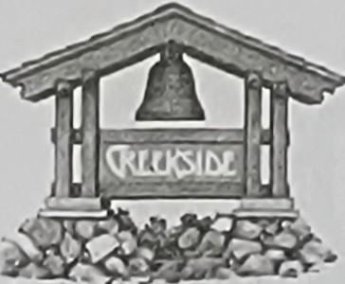

## RULES & REGULATIONS

required by the City of San Luis Obispo and/or State of California, must be obtained and submitted to management prior to the commencement of work.

1. **MOBILEHOME RESIDENCY LAW AND OTHER LAWS.** In addition to the information herein, resident's attention is directed to the MRL, which is incorporated by reference as though fully set forth herein and a copy of which will be provided to resident annually. A number of important provisions affecting all residents and Creekside are included in the MRL. Among the more important provisions are those concerning tenancy, mobilehome maintenance, transferring mobilehomes, public nuisance and rules and regulations. Resident must comply with all provisions of the MRl.
   1. Resident must also comply with all other applicable local, state and federal laws, which are incorporated by reference as though fully set forth herein, and the violation of which is a violation of these Rules.
2. **USE OF FACILITIES.** The clubhouse and other recreational and other facilities in Creekside are for the exclusive use and enjoyment of residents and guests, except as otherwise provided herein. Equipment and facilities are to be used in accordance with the rules posted therein.
3. **SOLICITATION.** Solicitation for commercial purposes is not permitted in Creekside, but solicitation for non-commercial purposes is permitted pursuant to Civil Code Section 798.51, as it may be revised from time to time. Residents may, for example, solicit for charitable or other non-profit purposes.
4. **MANAGEMENT AND OTHER CREEKSIDE REPRESENTATIVES.** Creekside shall be represented by management, including assistant managers, who are vested with authority to enforce these Rules on behalf of Creekside. Neither management, nor any other agent, representative or employee of Creekside, has authority to enter into any verbal agreement or understanding, to make any exception, or to approve any arrangement that is inconsistent with these Rules and the Lease Agreement. Management has no authority to make any representation or offer any opinion about the quality of any mobilehome. Creekside employees are prohibited from receiving any notices, mail, service of process, gratuities, deliveries, packages or other property from anyone for safekeeping, storage or any purpose.
5. **SUBLETTING AND RIGHTS OF HEIRS, ETC.** Resident may only sublease the space as allowed by Civil Code Section 798.23.5, or in the event that resident brings to Creekside's attention special circumstances that result in Creekside, in its sole discretion, approving a sublease, in advance and in writing. If a registered owner of a mobilehome will not be residing in the mobilehome, guests may not occupy or otherwise use the mobilehome without management approval, in advance and in writing. Subletting not allowed by Section 798.23.5 is not a right, but a privilege that may be rescinded at any time.
   1. The rights of heirs, joint tenants and personal representatives of the estate of a resident in the event of the death of the resident are stated in Civil Code Section 798.78. Such individuals may (1)

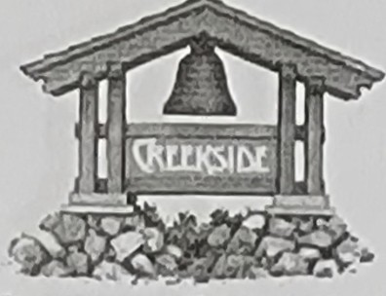

# RULES & REGULATIONS

sell the mobilehome to a third party if the resident's responsibilities to management regarding rent, utilities and reasonable maintenance of the mobilehome and space that have arisen since the death of the resident have been satisfied as they have accrued, (2) replace the mobilehome with another mobilehome or repair the mobilehome so it complies with applicable health and safety standards, or

(3) establish a tenancy in the park, so long as he or she is approved for such a tenancy. If the heir, joint tenant or personal representative does not satisfy the requirements of (1) above, the heir, joint tenant or personal representative may be required to remove the mobilehome from the park. The only situation in which the heir, joint tenant or personal representative becomes a resident of the park is (3) above.

1. **NO WAIVER FOR DELAY IN ENFORCEMENT OR ACCEPTANCE OF RENT.** If resident defaults on

any obligation or duty under these Rules or his or her Lease Agreement, a delay or omission in exercising any right or remedy management may have because of the default will not impair such right or remedy, nor will it be considered a waiver of any right or remedy. No waiver by management of the right to enforce any provision of these Rules or the Lease Agreement after any default on resident's part will be effective unless it is made in writing and signed by management, nor will it be considered a waiver of any rights to enforce each and every provision of these Rules and the Lease Agreement upon any further or other default by resident. Management has no authority to waive any rule or regulation, make any exception to a rule or regulation, or agree to any modification, deletion or alteration in any residency document without approval from Creekside, in advance and in writing.

* 1. Acceptance of rent shall not reinstate or create a tenancy. Conditional acceptance of rent pending approval of tenancy shall not be deemed to create a tenancy or waive any requirements applicable to tenancy, purchaser application or. approval requirements or assignment or transfer requirements. Acceptance of rent shall not constitute a waiver of any violation of these Rules, other grounds for termination of tenancy specified in the MRL, or any other right granted to Creekside. Acceptance of rent after service of a notice of termination as specified in Civil Code Section 798.57 shall not waive, affect or prejudice the notice, nor shall routine service of other notices, management communications or other actions or omissions of management waive, prejudice or affect the right to terminate tenancy, process a purchaser application and approve a tenant for tenancy, or otherwise affect the rights of management. Possession of rent by management shall not constitute acceptance thereof until such acceptance is approved by Creekside. Accordingly, the receipt by or tender of payment to management shall be conditional and for custody purposes only until approved by Creekside.
  2. No waiver by Creekside of its right to enforce any provision hereof, after resident's default, shall be deemed a waiver or estoppel of Creekside's right to enforce its rights upon any further default by resident. The acceptance of rent hereunder shall not be, nor shall it be construed to be, a waiver or estoppel of any breach of any term, covenant, rule or condition of these Rules or resident's Lease Agreement, nor shall it reinstate, continue or extend the term of the Lease Agreement or affect any notice, demand or suit thereunder.

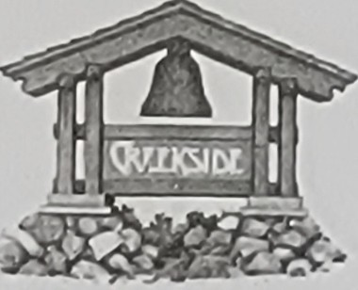

CREEKSIDE COMMUNITY

# RULES & REGULATIONS

1. **ENTRY UPON RESIDENT'S SPACE.** Management shall have a right of entry upon resident's space and mobilehome in keeping with Civil Code Section 798.26, as it may be revised from time to time. Management may not enter the space in a manner or at a time that would interfere with resident's quiet enjoyment thereof. Management may enter resident's mobilehome without the prior written consent in case of an emergency or when resident has abandoned the mobilehome.
2. **SWIMMING POOL.** Residents understand that the use of the pool and spa may be a hazard if those who use them are not careful. Residents further understand that the use of the spa may be a health and safety hazard to persons with certain medical conditions. Residents have been advised to consult with their physicians prior to using the spa.
   1. Residents further understand that there is no lifeguard on duty at the pool. Do not swim alone or while intoxicated. Residents further understand that any guests at the pool must be supervised at all times in order to avoid injury.
   2. Children fourteen (14) years of age and under may not use the pool or spa without direct supervision by an adult resident. No children are permitted in the pool or spa unless they are potty­ trained or wearing a swim diaper.
   3. Appropriate manufactured swimwear is required when in the pool or spa. No cut denim (also known as "cut-offs") or other attire not designed for swimming is permitted. Residents hereby release and indemnify management and its agents and employees from any and all claims for damages, injuries and otherwise, resulting from residents' use of the pool and spa. Residents further agree to hold management free and harmless from any and all liability and expense in connection with any injuries sustained by resident, any member of resident's family, any guest of resident, or any member of any guest's family, in the pool, spa or surrounding area. This release is intended as a full and complete release of any and all claims resulting from the use of the pool, spa and surrounding area, and it includes an agreement to release and indemnify management from any such claims in the future.
   4. Residents further release Creekside, its representatives and its agents from any and all claims for damages and/or injuries arising out of residents' use of the other recreational and other facilities in Creekside, and any damages and/or injuries caused by residents' guests, other residents or their guests.
   5. The undersigned hereby assumes full r_esponsibility for and risk of bodily injury, death or property damage while on Creekside premises and/or while using the premises or any facilities or equipment therein.
   6. Management may seek an injunction to prevent a resident or guest from behaving inappropriately at the pool, spa, surrounding area or elsewhere in Creekside. Should management do so, resident agrees that irreparable harm and the lack of an adequate legal remedy exists and need not be proved, established or evidence thereof proffered.

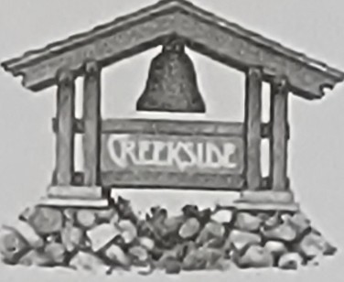

**C!lEEI\SIDE COMMUNITY**

# RULES & REGULATIONS

* 1. Spring, summer and fall pool hours are 8:00 a.m. to 10:00 p.m. Winter pool hours are 8:00

a.m. to 5:00 p.m. Pool covers will be used to maintain pool temperature during inclement weather. Covers must be completely removed prior to use..

* 1. Running, diving, jumping, acrobatics, horseplay and other boisterous activities that may cause injury or disturb enjoyment of the pool, spa and surrounding area by other residents and guests are not permitted. Balls, toys, rafts, inner tubes, scuba gear or other apparatuses are not permitted due to space limitations. Exercise aids such as kickboards are permitted when used properly.
  2. No glass or other breakable materials are permitted in the pool, spa or surrounding area.

1. **ACTIVITIES IN VIOLATION OF LAW.** Any activities by residents, guests or agents that would place Creekside in violation of any local, state or federal law will not be tolerated and may be deemed a public nuisance as provided in the MRL. Creekside will initiate any action necessary to prohibit, limit or stop such activities. The interference by residents with other residents or guests, the causing of disturbances, and the willful or careless injury to or destruction of property belonging to other residents or management, will result in prosecution under the terms of the MRL and all other applicable laws.
2. **CONTACTING MANAGEMENT AND COMPLAINTS.** Except in an emergency, please do not contact management after normal business hours, which are posted in the office. The office telephone is for business and emergency use only. The following guidelines apply to complaints by residents to management:
   1. Except in an emergency, all complaints must be in writing and signed by the person making the complaint. Complaints may be delivered to the office in person, faxed or mailed to the office, ore­ mailed to an e-mail address to be provided by management.
   2. Complaints must be submitted on a complaint form, or must include (1) the printed name and signature of the person making the complaint, (2) the date of the incident or situation, (3) the person(s) involved in the incident or situation, and (4) a description of the incident or situation.
   3. Creekside cannot take legal action to remedy the incident or situation complained about if it does not have written complaints on which to base the legal action. The name(s) of the complaining resident(s) will be kept confidential unless and until the situation or incident is turned over to the court.
   4. If any resident would like to send a complaint to the owner of Creekside as opposed to management, he or she may send it to a street address or e-mail address to be provided by management.
3. **GOOD FAITH COMPLIANCE REQUESTED.** Management requests that all residents comply in good faith with both the letter and the spirit of these Rules.